**Assignment 1**

class Vehicle2 {

    String make;

    String model;

    int year;

    int maximumSpeed;

    public Vehicle2(String make, String model, int year, int maximumSpeed) {

        this.make = make;

        this.model = model;

        this.year = year;

        this.maximumSpeed = maximumSpeed;

    }

    public void drive() {

        System.out.println("Driving a vehicle");

    }

    void display() {

        System.out.println("Make: " + make);

        System.out.println("Model: " + model);

        System.out.println("Year: " + year);

        System.out.println("Maximum Speed: " + maximumSpeed + " km/h");

    }

}

class Car2 extends Vehicle2 {

    public Car2(String make, String model, int year, int maximumSpeed) {

        super(make, model, year, maximumSpeed);

    }

    @Override

    public void drive() {

        System.out.println(make + " " + model + " Car is driving");

    }

}

class Bike2 extends Vehicle2 {

    public Bike2(String make, String model, int year, int maximumSpeed) {

        super(make, model, year, maximumSpeed);

    }

    @Override

    public void drive() {

        System.out.println(make + " " + model + " Bike is driving");

    }

}

class VehicleMain1 {

    public static void main(String[] args) {

        Car2 car = new Car2("Toyota", "Corolla", 2020, 180);

        Bike2 bike = new Bike2("Yamaha", "MT-07", 2021, 200);

        System.out.println("Car Details:");

        car.display();

        car.drive();

        System.out.println("\nBike Details:");

        bike.display();

        bike.drive();

    }

}

**OUTPUT:**

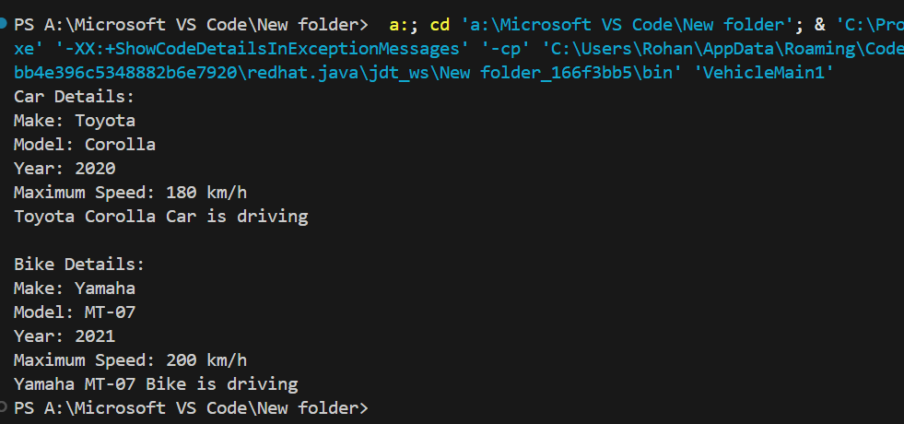

**Assignment 2**

public class Shape {

    void getArea(){

    }

}

class Circle extends Shape {

    int radius;

    Circle(int radius) {

        this.radius = radius;

    }

    @Override

    void getArea() {

        double area = Math.PI * radius * radius;

        System.out.println("Area of Circle: " + area);

    }

}

class Square extends Shape {

    int length;

    Square(int lelength) {

        this.length = length;

    }

    @Override

    void getArea() {

        int area = length * length;

        System.out.println("Area of Square: " + area);

    }

}

class ShapeMain{

    public static void main(String[] args) {

        Circle circle = new Circle(5);

        Square square = new Square(4);

        circle.getArea();

        square.getArea();

    }

}

**OUTPUT:**